SAVEETHA SCHOOL OF ENGINEERING
CSA15- CLOUD COMPUTING AND BIG DATA ANALYTICS
LIST OF EXPERIMENT 1
Name: Edrin J S
Register Number:192524041
Course Code:CSA1504
1. Build a basic cloud-based software application and make it available as a service through any Cloud Service Provider, thereby demonstrating the Software as a Service (SaaS) model.
SOL:
AIM:
To design and build a lightweight cloud-hosted application using Zoho Creator and roll it out as a Software as a Service (SaaS) application, so that users can view and manage data through any standard web browser over the internet.
PROCEDURE:
- Log into Zoho Creator with a valid Zoho account.
- Start a new app by choosing either a Blank Application or a ready-made template.
- Build the necessary input forms, including fields like text, number, date, and email.
- Set up reports that let you view, search, and manage the saved records.
- Where needed, add automation rules or workflows, such as validation checks or email alerts.
- Assign user roles and permissions so access to the app is properly controlled.
- Publish the finished application onto the Zoho cloud platform.
- Open the application from its web link on multiple devices to confirm it works from the cloud.
- Check the app's functionality by creating, updating, viewing, and removing records.

SNAPSHOTS:
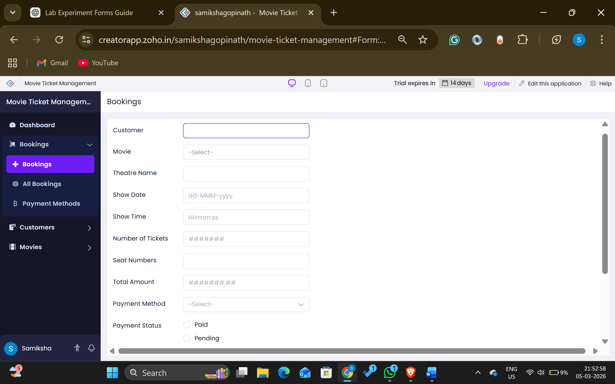
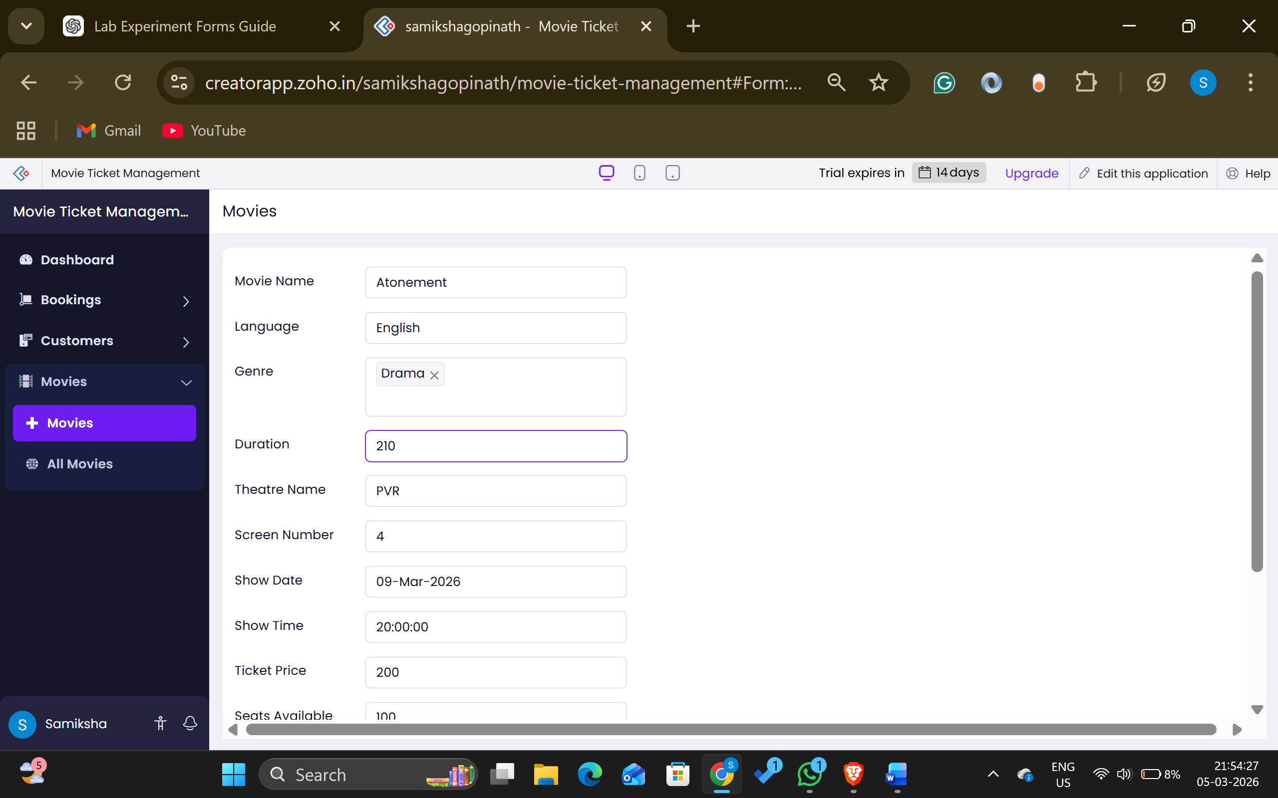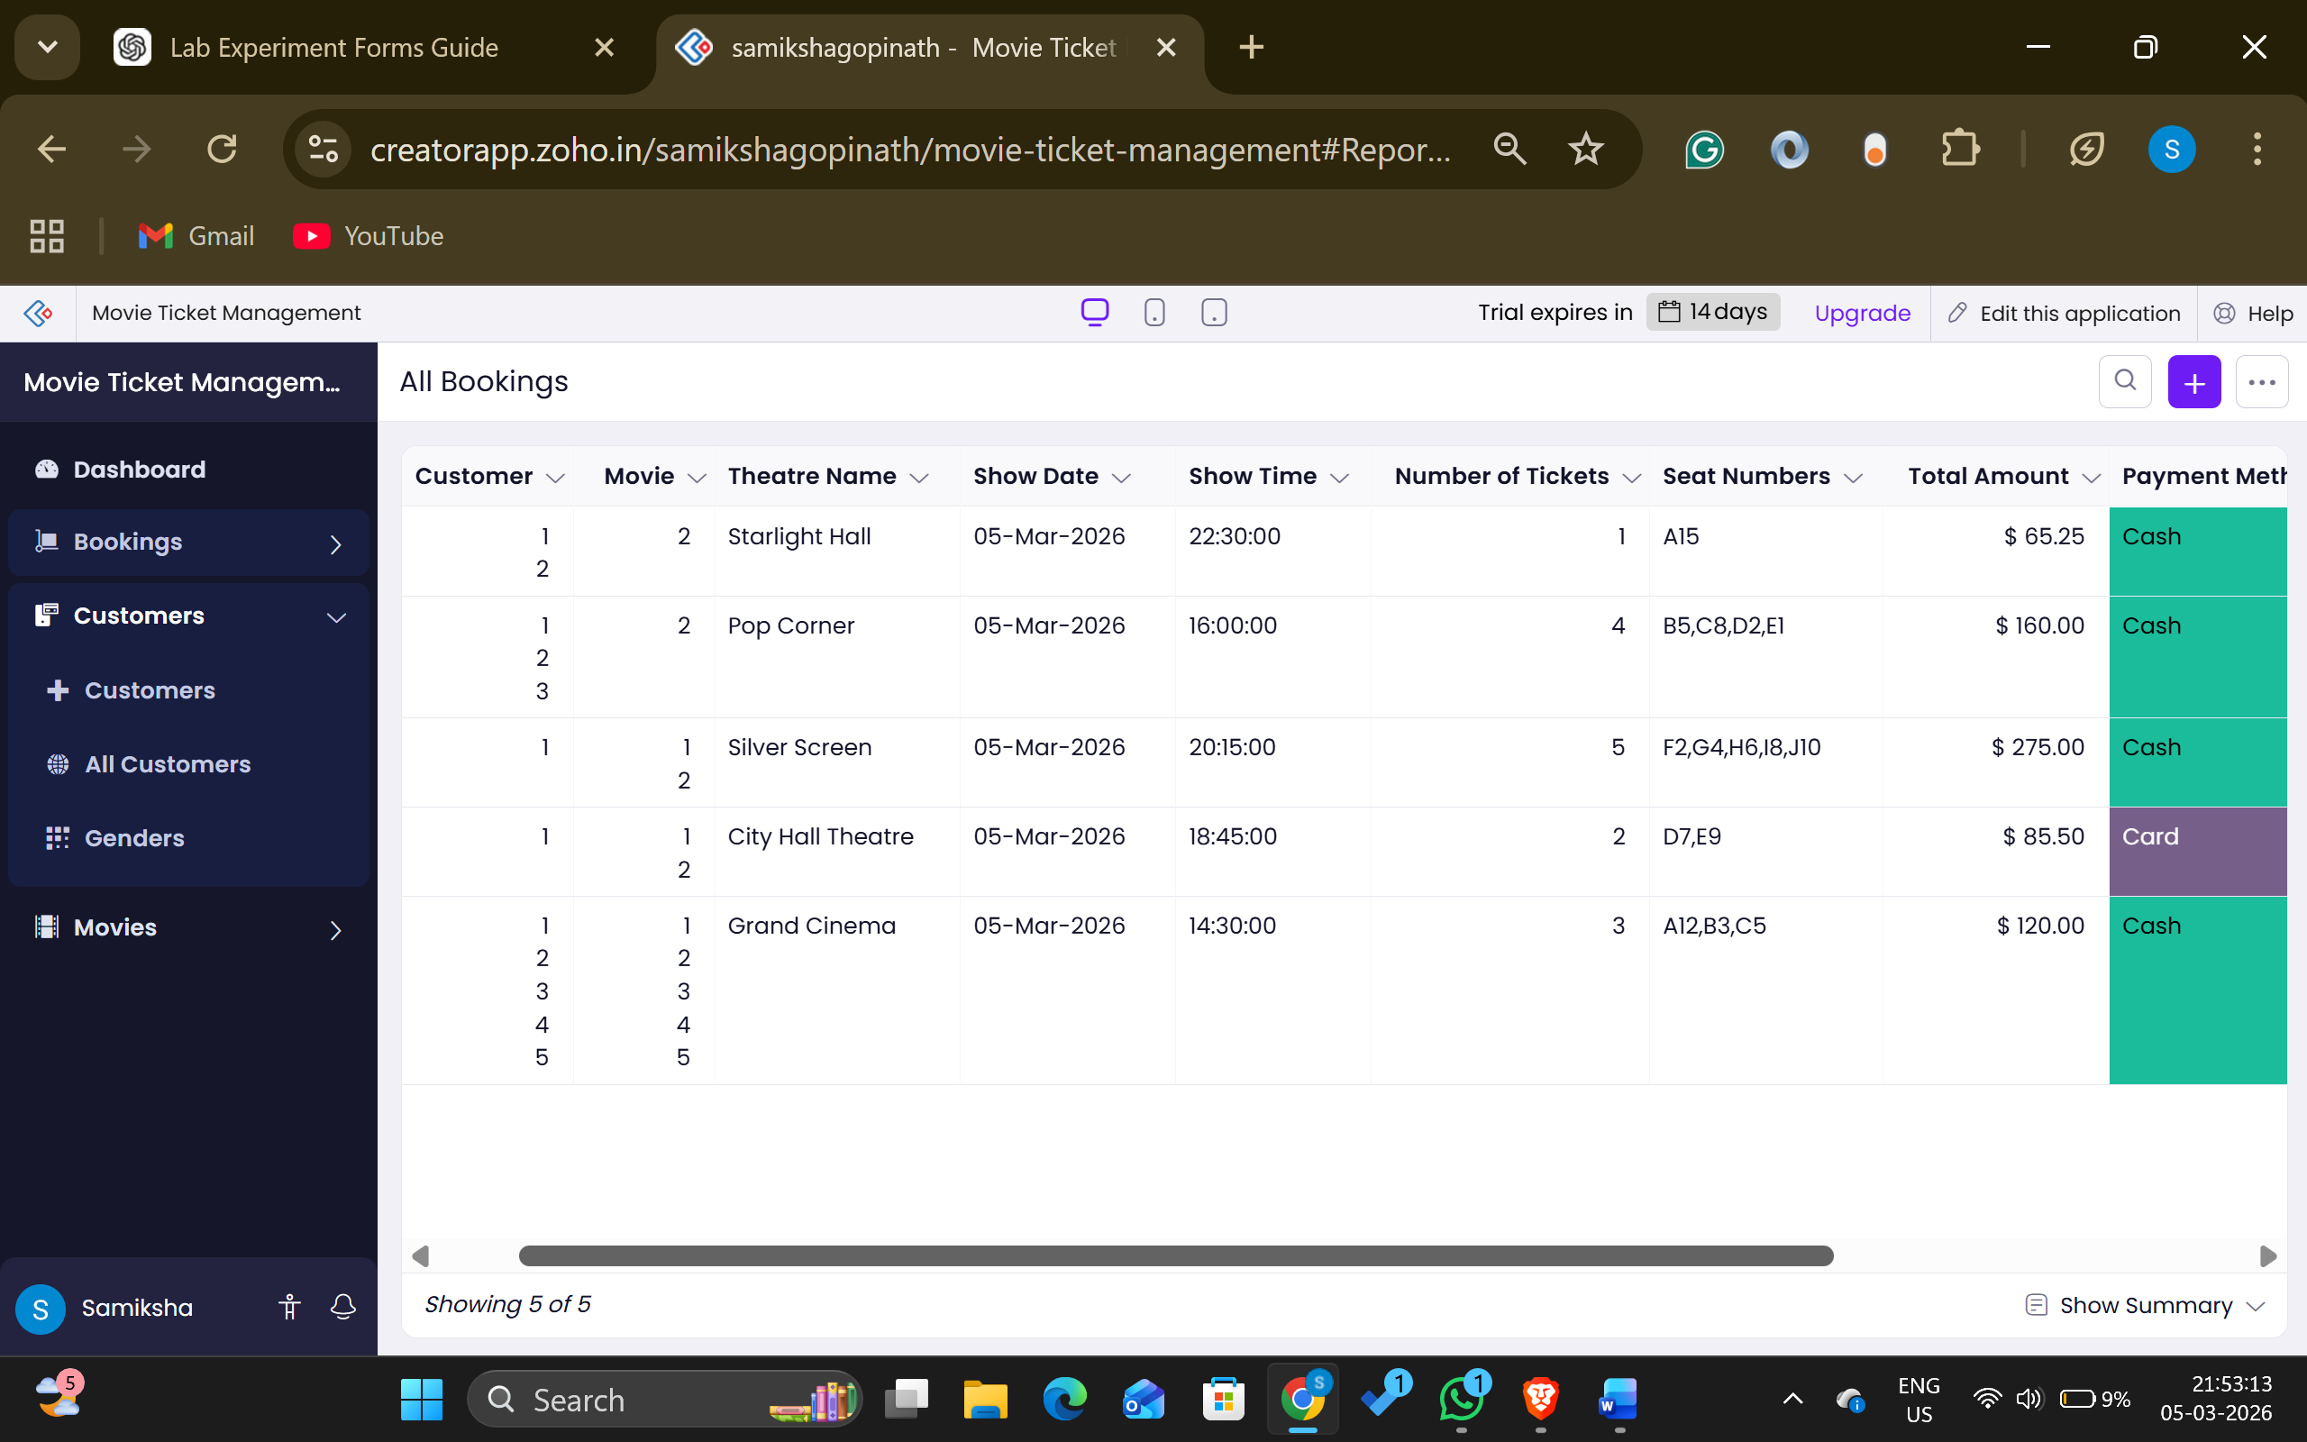

RESULT:
A lightweight cloud-based application was built and successfully deployed using Zoho Creator. It could be accessed online through a web browser, confirming the Software as a Service (SaaS) model, as users were able to use the software without any local installation.

